Do you love books?
Do you have some spare time?

We urgently need volunteers to sort & scan the many books that our wonderful supporters donate to us!
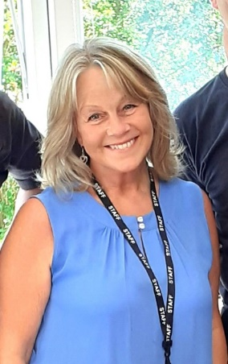
If you can help,
please contact Julie.
juliemills@emmausvc.org
Tel: 07954.577.820

