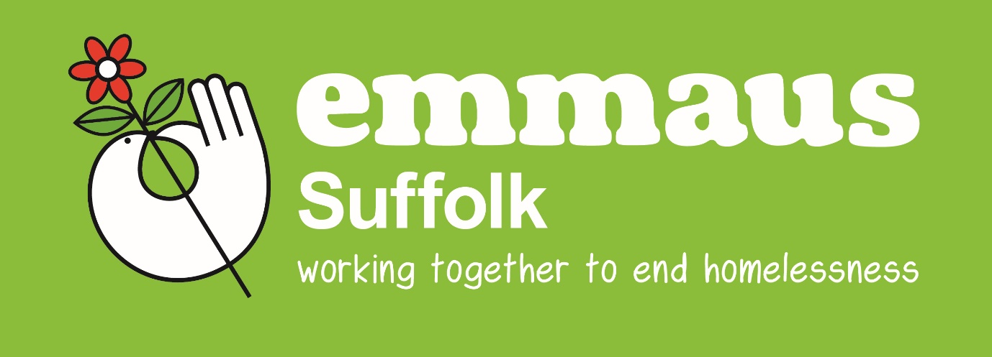
About Emmaus Suffolk
Contents:
- Emmaus in the UK
- Emmaus Suffolk
- The Emmaus Suffolk Model
- The Social Enterprises
The Emmaus Movement in the UK
Every Emmaus Community in the UK is a separate registered independent charity under the umbrella organisation, Emmaus UK, that offers advice and support to all Emmaus projects across the UK and raises funds nationally to support the growth of the Emmaus Movement.
Emmaus Suffolk today
Emmaus Ipswich evolved into Emmaus Suffolk in Oct 17. As with other Emmaus communities, the objectives of the charity are the alleviation and relief of poverty, hardship and distress that arises as a result. The organisation does this by offering meaningful activity for homeless, socially-isolated and long term unemployed people (beneficiaries) as appropriate, providing education, training and work opportunities
The beneficiaries have the opportunity to develop their skills to enable them to gain employment in the future, and a sense of self-worth and dignity through having a self-supporting life. In the long term this will include the provision of accommodation, or assistance in such provision for the beneficiaries.
The overarching aim is to become a self-sustaining business and service provider. Through providing meaningful occupation Emmaus creates for people, a means of gaining experience, training and transferable skills, building self-respect and personal empowerment. At the same time, it provides choice and access to good quality furniture and household goods for both low income families and the wider community.

Making a difference locally.
We work with vulnerable individuals whom are homeless, vulnerably housed and/or workless. These individuals often do not identify they have support needs but work with our support workers. We have an holistic approach around each individuals wellbeing – both within the organisation but more importantly within the wider external community. ie how they cope day to day when they are not working here.

The Support Team works with the variety of needs of the individual, signposting to other organisations when necessary for specialist intervention. We view ourselves as the stepping stone for building confidence and skills for individuals to move on into independent living, employment, dealing with relationships etc. We build both social and work skills in a safe environment, to create a gateway to independent living.

Through our Community Hubs in Ipswich and Felixstowe we run opportunities for community experiences, leisure activities, networking both with local businesses and services. Activities include crafting, upcycling, seasonal activities etc along with Gardening Club at two of our sites with out door space. We also offer opportunities for Work experience, Duke of Edinburgh and university placements.

Our current Social Enterprises:
The Dales: Donation centre and shop open to the public 10am – 4pm Tues – Sat.
Sailmakers: Retro and Vintage Emporium. Open Mon – Sat 10.30am – 4.30pm
The Royal Oak: Retail and Community Café. Open Tue – Sat 10am – 4pm
Dog Street: Furniture retail only – Open Wed – Sat 10am -4pm (New Venture for Oct 22)
Felixstowe: Retail with furniture – open Wed – Sat 10am-4pm
All Retail outlets offer furniture, bricabrac, clothing, electrical items, upcycled items, along with our ethical product ranges; Sesi Refillables (domestic vegan friendly cleaning products) and Remix paint (furniture chalk paint made from recycled paint).
The Hubs
Unit 32 – Sailmakers – Ipswich Town Centre
Old Felixstowe Community Centre
Great Eastern Square Felixstowe Café
The Royal Oak
- Activities and events for the community happen every week. Free meeting space for local community groups to use.
- Community Gardens – wheelchair friendly wildlife garden open all year.
- Shower & laundrette facilities for our companions and also individuals referred from partnership organisations in the locality only by appointment at the Dales.
- Upcycle Workshop – furniture items are repurposed and improved for sale using remix chalk paints. This is both a voluntary opportunity plus we have public paid for sessions and partner organisation events.
House Clearance across Suffolk – Offering a cost effective and compassionate service for house clearance and disposal. This will primarily enhance the opportunities for NRC’s to gain different work experience but it will also generate additional income contributing to our self-sufficiency intentions.
Micro Housing Project – We opened a social housing model during the first Covid-19 lockdown. This housing opportunity offers a holistic approach to accommodation, support and meaningful activities, both in the social enterprises and in with wider local community.
Our track record and impact in our first 5 years.
We have:

- Worked with 398 separate vulnerable individuals
- Supported 1722 issues with 3813 interventions
- 38 volunteers have moved on into work
- 14 volunteers have been supported into housing
- 9 paid staff
- 5 paid staff within the business started as service user.
- 25 volunteers have moved on into further education

What are the long-term ambitions for Emmaus Suffolk?
We have a vision for the next five years based on three priority areas:
Priority Area 1: Grow our support offer and increase vocational qualifications opportunities.
Priority Area 2: Develop a high-quality micro housing offer.
Priority Area 3: Continue to scale up our social enterprises.
At the beginning of 2021 we were successful in securing Reaching Communities funding for 3 years to develop these three priorities. We have taken on a new site the Royal Oak in Ipswich to deliver on these areas by opening a new Hub, offering a 4 bedroom housing offer on site and opening both a Retail and a Community Café.
Find out more on our website www.emmaussuffolk.org.uk
Trustee application for Emmaus Suffolk:

The strategic and financial remit of Emmaus Suffolk Board is set out in its Articles of Memorandum. The board is Unitary and will concentrate on Suffolk- wide needs. The board members will be responsible for the evolution of the Charity working with the Chief Executive, to develop the non-residential companion model and increase its social enterprises. It will do this at a variety of locations that will offer non-residential companion the opportunity to volunteer within their own localities. We will be providing business opportunities and experience to give people the chance to rebuild their lives in a supportive, enduring environment.
Along side this we will develop the pioneering micro housing offer for UC and Full Companions enabling people to move from supported housing provision towards independent living. The development of an Emmaus Suffolk accommodation strategy, against the background of constant changes in benefits provision will be critical. The overarching aim is to become a self-sustaining county wide social enterprise, service and housing provider.
As a homelessness charity, we naturally expect all trustees to have a good understanding of, and commitment to, homelessness and those that are vulnerably housed. We are particularly seeking trustees with any of the following skills and experience:

Retail / Marketing  Catering/Food  Funding applications  Property – Residential  Social Care / vulnerable people  Homelessness  Voluntary Sector Experience  Business Development | Legal: H&S/ Charity Governance/Equal Ops/ Commercial & Business  Property: Development/Planning  Facilities management  HR/ Recruitment  Fundraising / Appeals

Trustees should demonstrate:
Personal Qualities
- A strong and visible passion and commitment to the charity, its strategic objectives and cause, and have personal gravitas to instil confidence in being able to represent the organisation
- Exhibit strong communication and interpersonal skills, plus strong networking capabilities that can be utilised for the benefit of the charity
- Demonstrate tact and diplomacy, with the ability to listen and engage effectively and promote a collaborative team environment
- Ability to commit time and effort to conduct the role well, including travel and attending events out of office hours.

Experience

- Successful track record of career achievement
- Experience of governance, ideally within a charity, and working with or as part of a board or other committee and/or team-working
- Experience of external representation, delivering presentations and managing stakeholders. Knowledge and skills
- An understanding and acceptance of the legal duties, responsibilities and liabilities of trusteeship Broad knowledge and understanding of the wider Civil Society sector and current issues affecting it Strong leadership skills, ability to motivate staff and volunteers and bring people together
- Financial management expertise and a broad understanding of charity finance issues.

Additional information:
The above is indicative only and wider skills and experience will be considered. The trustees will be expected to perform all such additional duties as are reasonably commensurate with their role, and to employ any specific skills and expertise they have for the benefit of Emmaus Suffolk.

Remuneration:
The roles of trustee is not accompanied by any financial remuneration, although expenses for travel may be claimed.

Applications:
Candidates will be invited to informally meet the Emmaus Suffolk’s current Chair Harriet Cadman, as part of the selection process and to attend the next board meeting as our guest.
Please send us:
- A comprehensive up-to-date CV, including details of two referees, who will not, of course be contacted without your knowledge or consent;
- A supporting statement, highlighting your motivation for applying and what you feel you could bring to this role
- A completed Skills Audit.
Board meetings are held bi-monthly and are a blended offer of on site in Ipswich and zoom meetings. They are approx. 2 hours long and are held in the early evening. Board members will be expected to support the Chief Executive by participating in task and finish groups according to their skills, experience and interests. These will be held additionally to the board meetings.
There is an annual AGM and an annual Strategic Day where all Board Members are asked to attend. Dates will be confirmed annually.

