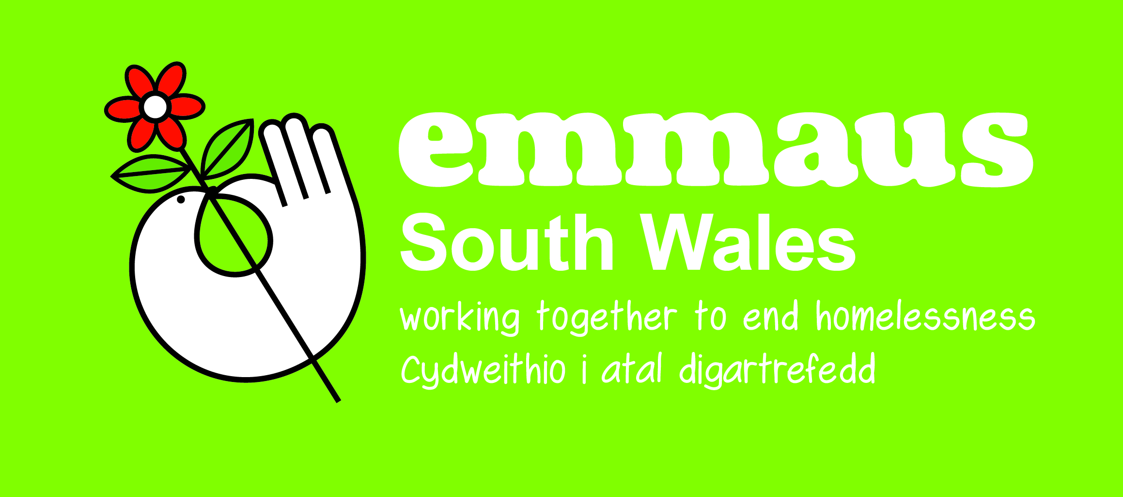
Job Description &
Person Specification

Job Title: | Van Driver
Reports To: | Superstore Store Manager (in their absence, Head of Retail)
Organisation: | Emmaus South Wales
Location: | Bridgend, CF31 1TZ
Hourly Rate: | £9.70 (£18,915 per annum)
Date: | September 2021

Summary of role:

- Primarily collecting & delivering furniture items but items may also include clothing, Bric-A-Brac and electrical appliances. This role also involves the servicing of other Emmaus South Wales locations and the rotation of stock and clearance of waste.
- Driving company vehicles. This includes driving 3.5-ton Luton type box van with tail lift.

Job Dimensions:

- Operating days: Monday to Sunday (5 days on duty)
- Supervising a small team of companion and placement van crew
- Number of volunteers: 1 – 3
- Lead and teach teamwork by example

Key responsibilities:

- Action daily van checks as per guidelines to ensure standards are achieved and maintained.
- Ensure the highest standards of service are delivered to customers daily.
- To raise awareness of Gift Aid and complete necessary paperwork when collecting items.
- Manage a team of companions and/or volunteers to assist you to lift a multitude of furniture items into and out of properties.
- To effectively plan the most cost-efficient route when delivering/collecting items.
- To drive to a high standard, displaying consideration for other road users and wear and tear of Emmaus South Wales’ vehicles.
- To work closely with shop managers/deputies to ensure the correct items are delivered and only suitable items are collected.
- Coordinate, supervise and train Companions and placements to ensure high quality customer service when interacting with the public.
- Develop and foster a team environment based on respect and mutual support to achieve the team goals.
- Contribute to the growth of revenue and maximisation of profit from effective and customer focused operations
- To effectively carry out house clearances as and when required.
- To support Emmaus in effectively sorting and recycling waste including transporting waste and recycling to a local contractor.
- During quieter periods, to support colleagues by effectively working in the shop or community.

Administration, Finance & Security

- Notify local police, store manager, head of retail and head office in the event of a break in, theft or security incident.
- Notify the shop manager and head of retail in the event or suspected theft or dishonesty by any member of staff.

Volunteers, Companions and Placements:

- Keep all volunteers and companions up to date with any Emmaus South Wales communications, promotions, and information.
- Ensure all volunteers and companions are complying with Emmaus South Wales Standard operating procedures.
- Ensure all equality and diversity policies are adhered to and any training is passed onto volunteers and companions.
- Support the learning, skills development, and engagement in work activities of Companions and placements.

Health & Safety:

- Responsible for Health & Safety for all activities associated with loading, unloading, driving, and maneuvering of vehicles including use of tail lift, driving skills, movement of goods within organisation’s premises and at customer premises, and ensuring all members of the vehicle team take their responsibility for Health & Safety seriously
- Maneuver, lift and carry furniture and domestic goods to and from vehicles, in and out of buildings, and up and down stairs. Also supervise and work with others doing this.

Special Requirements:

- The ability to lift and move heavy objects.
- A requirement to support solidarity activities undertaken by the Community.
- To lead by example by demonstrating appropriate behaviour, values, and culture and create a positive working environment.
- Any other duties as required by the Store Managers including additional duties and responsibilities to cover for holidays and absences.
- The ability to mange difficult situations and people.
- A requirement to learn and engage with the Emmaus ethos as presented in the Universal Manifesto and embodied in the history and experience of all involved in Emmaus.
- Emmaus South Wales is working towards becoming more sustainable in the future, we ask all employees to act sustainably in store by adopting strict controls around waste, using resources more efficiently and reducing the number of unnecessary resources we use daily.

Essential | Desirable
- Valid Driver’s Licence with at least 2 years driving experience, including authorisation to drive 3.5 tonne Luton vans.  - Effective verbal/listening communication  - Ability to stay calm and cope under pressure  - Computer skills, including Excel and Word  - Working as part of a team with range of people without prejudice  - Customer service experience, dealing with difficult customers  - Experience of map reading/navigation.  - Effective team member, with the ability to lead, work and delegate  - Able to work with range of people without prejudice  - Self-motivated  - Ability to understand and maintain appropriate professional boundaries | - Customer Care; Dealing with Difficult Customers  - Knowledge of relevant Health and Safety  - Computer skills, including Excel and Word  - Scheduling rotas  - Fleet maintenance  - Recycling or second-hand retail experience  - Stock management  - Working with vulnerable people or people with challenging behaviors  - Training and development of others

Solidarity within the context of Emmaus is the working with groups and individuals towards the alleviation of poverty, social exclusion and suffering and responding to local, national and international appeals for relief and support.
The English version of the Universal Manifesto is available at http://emmaus-international.org/ under ‘Our Publications’

