About Emmaus

Our vision: A world in which everyone has a home and a sense of belonging

Emmaus is a homelessness charity with a difference. We don’t just give people a bed for the night; we offer a home, meaningful work and a sense of belonging.

For many people who have experienced homelessness, losing their self-esteem can be the most damaging part of their experience. Being on your own, with no support around you can be soul-destroying, leaving you feeling worthless.

Finding your way out of that situation isn’t easy, particularly when the only options available are temporary fixes, offering a bed for the night but little to occupy your days.

Emmaus is different because it provides a home for as long as someone needs it, in an Emmaus community. This gives people the opportunity to take stock of their lives, deal with any issues they might have, and often re-establish relationships with loved ones.

“Companion” is the name given to those who live in an Emmaus community and work in the social enterprise, where they support themselves and one another. There are currently 750 companions living at 29 Emmaus communities across the UK.

Rather than relying on benefits, Emmaus uses social enterprise to generate revenue that pays for companions' home, food and upkeep, as well as providing a small weekly allowance. This is key to restoring feelings of self-worth, showing companions that their actions make a real difference, both to their own life, and the lives of others.

How it works

Unlike a lot of provision for homeless people, Emmaus communities offer a home for as long as someone needs it. This includes a room of their own, food, clothing and a small weekly allowance.

In return, we ask:
- That companions work for 40 hours per week, or give as much time as they are able, in the community's social enterprise;
- That they behave in a respectful way towards one another;
- That no alcohol or illegal drugs are used on the premises;
- That they sign off all benefits, with the exception of housing benefit.

Our impact

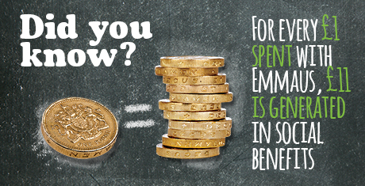
Emmaus doesn’t only have a significant impact on the lives of people who have experienced homelessness and social exclusion, it also brings wider social and economic benefits.

Research carried out in 2012 found that for every £1 invested in an established Emmaus community, £11 is generated in social, environmental and economic returns.

The benefits included:
- Keeping people out of hospital, and helping them to be safe and well, saved the Department of Heath £1,478,506 for NHS and emergency service costs;
- Emmaus saved local government £2,447,612 which would have been spent on hostel accommodation, drug and alcohol services and landfill;
- Keeping people in work and out of prison saved the Ministry of Justice £778,435.

The report found that Emmaus communities successfully provide a place for people in vulnerable housing situations to rebuild their lives by offering them meaningful work and support. Significant benefits were linked to substantial improvements in companions’ physical and mental health, including reductions in substance misuse.

Emmaus South Wales

Emmaus South Wales is still relatively new in the Emmaus movement. Established as a Charity and Social Enterprise in 2012, the Community House ‘Nant Lais’ based in Cefn Glas, Bridgend opened in 2016.
Nant Lais provides a home and community for up to 24 Companions. Our Social Enterprise currently comprises of 5 retail outlets two in Bridgend, one each in Porthcawl, Cowbridge and Maesteg, as well as an eBay shop, and house clearance service. The social enterprise provides Companions with meaningful work to both support themselves and offer solidarity and support to others in need.

