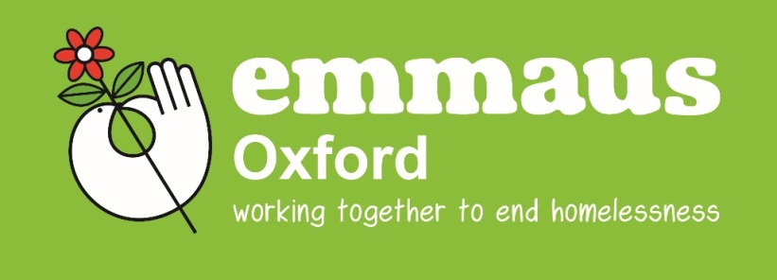
APPLYING FOR A PLACE AT EMMAUS OXFORD

In Emmaus Oxford people who have been homeless come together to live and work as part of a community, becoming ‘companions’ when they join us. The community is made up of 28 men and women who come from all over the UK and beyond. When joining us as a companion we ask everyone to agree to:
- Volunteer to work full time within Emmaus Oxford
- Be prepare to sign off state benefits [with exception of Housing Benefit where applicable]
- Abide by the rules of no drugs or alcohol on the Emmaus Oxford sites
- Respect other people
- Move on with our support when ready to do so.

The criteria for applicants to Emmaus Oxford is as follows:
- To be over 18
- To be either homeless or at risk of becoming homeless, or to have been referred by another project catering for the same
- To be off illegal drugs
- Not dependent on alcohol
- To be able and willing to work 35 hours a week
- To be willing to come off benefits (except for Housing Benefit)
- To be able and willing to claim Housing Benefit (unless they are applying for a ‘solidarity’ place)
- To be able to live in Community and fit in with its current composition
- To have enough independence to cope with periods where there are no staff present
- To be willing to live by our rules
- To want to contribute.

We provide 24 comfortable en-suite single rooms [plus 4 rooms in an attached annex], all food, toiletries and work clothes as well as a yearly training budget. We provide a weekly allowance and will help you to start a ‘leaving fund’. Each companion is given a keyworker and you will work together to develop a support plan which addresses specific issues and supports personal development. We expect companions to move out of our accommodation when they no longer need it and we will work with you to set goals with this aim in mind.

Emmaus Oxford is not a homeless hostel and the communal living aspect along with the strict rules regarding alcohol and drugs mean that we are not for everyone. We accept people who have no active addictions and low to medium support needs. We work on a referral basis in two stages. Please provide full details on the attached form including the contact details of all those who are, or have been, involved in the support of the applicant. Please also ensure that the consent form is signed by the applicant to allow information on the form to be confirmed by contact with agencies and people included on the application form.

This is stage one of two in applying to Emmaus Oxford. We will let you know the result either way. If we have room and feel we may be able to help we will invite you to an interview and a visit before doing a full assessment. If you have any questions, please do not hesitate to contact us on 01865 402 073 (option 2 then option 1) or referrals@emmausoxford.org
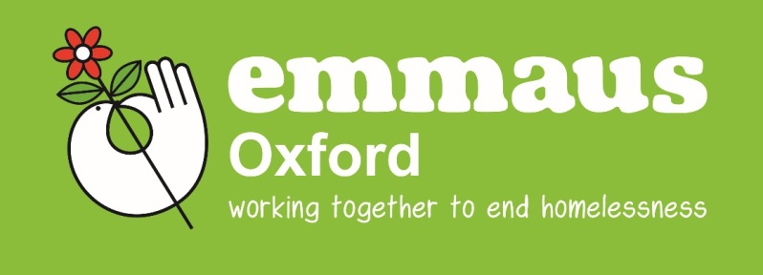
FOR OFFICE USE ONLY
Date received:_____________

Received by:___________________
INITIAL REFERRAL FORM

APPLICANT NAME
DATE OF BIRTH: |  | AGE:
GENDER | MALE | FEMALE
NATIONAL INSURANCE NO:
CONTACT ADDRESS:
CONTACT NUMBERS
(INCLUDING MOBILE):

REFERRER’S DETAILS

NAME:

POSITION:

AGENCY:

CONTACT ADDRESS:

CONTACT NUMBERS
(INCLUDING MOBILE):
EMAIL:

DATE OF APPLICATION: _______________________

Please be as honest as possible when answering the following questions. We will not be prejudiced against you by anything you tell us here. We will use this information to decide if we can support you and how best to do so.

IF APPLICANT IS CURRENTLY IN PRISON, PLEASE STATE WHICH PRISON, ID NUMBER AND RELEASE DATE:

IF RECENTLY RELEASED FROM PRISON, PLEASE STATE WHICH PRISON, RELEASE DATE, DETAILS OF LICENCE PERIOD AND PROBATION INFORMATION:

YOUR STORY.....

Please give a brief account of your life history up till this point. How did you become homeless? Where have you lived? What are the problems/issues that have arisen for you in the past?
What is your country of birth?______________________________________

If you haven’t always lived in the UK, please state how long you have been in the UK: _____________

Are you eligible to receive housing benefit: YES/NO
You must be able to receive housing benefit in order to reside at Emmaus Oxford. In certain circumstances, places may be available for those with no recourse to public funds or individuals in full time employment. Please discuss this with a member of staff if either of these circumstances apply to this application.

If you are not eligible to receive housing benefit, please state reasons why and your current situation to include information with regards to any appeals made/ongoing:

Have you ever lived in an Emmaus community? YES/NO

If answering yes, please tell us which community / communities and the dates you lived there. What were your reason(s) for leaving?

Have you applied to any other Emmaus communities? If so, when?

Why do you want to be a Companion at Emmaus Oxford?

If you come to Emmaus Oxford you will be living with other people and sharing facilities as part of our community. Have you ever lived in this way before?

Please give details of any previous employment, training and skills that you have:

What would you like to get from living and working at Emmaus Oxford? This might be qualifications, a particular type of job or skills like budgeting or cooking.

Do you have a driving licence? YES/NO

Do you have a passport? YES/NO VALID/EXPIRED

Do you have a birth certificate? YES/NO

Is there anything else you would like to add? Please include anything that you feel might support your application:

Please give details of a person we can contact for a reference. The reference person must be a recognised professional who has worked with you and knows you. This can be the same person who is referring you.
REFERRER’S DETAILS (If different from those on page 1)

NAME:

POSITION:

AGENCY:

CONTACT ADDRESS:

CONTACT NUMBERS
(INCLUDING MOBILE):
EMAIL:

Thank you for applying to Emmaus Oxford.

We will be in touch to let you know what will happen next.

