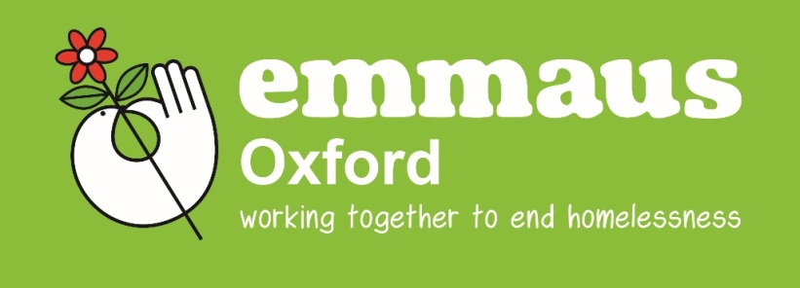
APPLICATION INFORMATION FOR A PLACE AT EMMAUS OXFORD
Based in a purpose built building near the centre of the city, Emmaus Oxford is a different concept in services for homeless people. Here, people come together to live and work as part of a community – becoming “Companions” when they join us. The community is made up of 28 men and women who come from all over the UK and beyond. In joining us though, everyone must agree to:
- Volunteer to work full time within Emmaus Oxford
- Sign off state benefits [with exception of Housing Benefit where applicable]
- Abide by the rules of no drugs or alcohol on the Emmaus Oxford sites
- Respect other people

The criteria for applicants to Emmaus Oxford is as follows:
- To be over 18
- To be either homeless or at risk of becoming homeless, or to have been referred by another project catering for the same
- To be off illegal drugs
- Not dependent on alcohol
- To be able and willing to work 35 hours a week
- To be willing to come off benefits (except for Housing Benefit)
- To be able and willing to claim Housing Benefit (unless they are applying for a ‘solidarity’ place)
- Not to have a serious mental health problem
- To be able to live in Community and fit in with its current composition
- To have sufficient independence to cope with periods where there are no staff present
- To be willing to live by our rules
- To want to make a contribution

We provide 24 comfortable en-suite single rooms [plus 4 rooms in an attached annex], all food, toiletries and work clothes as well as a yearly Emmaus led training budget of £250 with an additional £250 for personal development training. We provide a weekly allowance of £39 with an additional £7 being put into a “leaving fund”. Each companion is linked with a 1:1 worker and together they agree a support plan to address specific issues and allow personal development, as well as set a tailored plan for the future.

Emmaus Oxford is not a homeless hostel and the community living aspect along with the strict rules regarding alcohol and drugs mean that this is not an option appropriate for everyone. We can accept people who have no active addictions and low – medium support needs. However, we only work on a referral basis so it is essential that full details are provided on the attached form including the contact details of all those who are, or have been, involved in the support of the applicant. Please also ensure that the consent form is signed by the applicant to allow information on the form to be confirmed by contact with agencies and people included on the application form. It is only then that we are able to carry out a full assessment and proceed to the interview stage of the application, with a visit to Emmaus Oxford.

We are currently accepting referrals for consideration, so please complete the attached form and return it to us. Alternatively, if you have any questions, please do not hesitate to contact us and we will be happy to help.

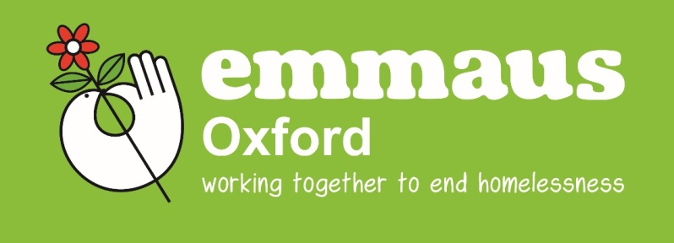
DATE COMPLETED/
RECEIVED:_____________
COMPLETED BY:___________________
APPLICATION FORM
All information provided will be treated with respect and will be held in strictest confidence, subject to the
Data Protection Act 1998 and the General Data Protection Regulations [GDPR] 2018. Emmaus Oxford is committed to protecting your personal information. To find out more, please read our companion privacy statement www.emmaus.org.uk/oxford/privacy. Please also read the privacy statement for Emmaus UK www.emmaus.org.uk/privacy an

NAME: DATE:
________________________________________________ ___________________

DATE OF BIRTH: |  | AGE:
GENDER | MALE € | FEMALE €
NATIONAL INSURANCE NO:
CONTACT ADDRESS:
CONTACT NUMBERS
(INCLUDING MOBILE):

REFERRER’S DETAILS

NAME:

POSITION:

AGENCY:

CONTACT ADDRESS:

CONTACT NUMBERS
(INCLUDING MOBILE):
EMAIL:

Please be as honest as possible when answering the following questions. The information we gather is not to be prejudice against you. We mean to use it to help support you better.

IF CURRENTLY IN PRISON – PLEASE STATE WHICH PRISON, ID NUMBER AND RELEASE DATE:

IF RECENTLY RELEASED FROM PRISON – PLEASE STATE WHICH PRISON, RELEASE DATE, DETAILS OF LICENCE PERIOD AND PROBATION INFORMATION:

HOUSING/HOMELESSNESS HISTORY:
YOUR STORY.....
Please give a brief account of your life history up till this point. How did you become homeless? Where have you lived? Problems/issues that have arisen in the past?

Have you lost accommodation in the past? Please give details:

What is your country of birth?_______________________________________________________________

If you haven’t always lived in the UK, please state how long you have been in the UK:
_______________________________________________________________________________________

Are you eligible to receive housing benefit: YES/NO
You must be able to receive housing benefit in order to reside at Emmaus Oxford. In certain circumstances, places may be available for those with no recourse to public funds or individuals in full time employment. Please discuss this with a member of staff if either of these circumstances apply to this application.

If you are not eligible to receive housing benefit, please state reasons why and your current situation to include information with regards to any appeals made/ongoing:

Have you ever lived in an Emmaus Community? YES/NO
If answering yes, please give information regarding which communities and dates and reason for leaving:

Please list any Emmaus Communities that you have applied to including dates of application:

SUBSTANCE MISUSE HISTORY:

Have you had, or still have problems with drugs? YES/NO If answering No, please go to next section.

What drugs do you currently use? How much/How often?

What drugs did you previously use? How much/How often?

If not currently using drugs, how long have you been “clean”?

If not currently using drugs, have you had any recent lapses? YES/NO
If Yes, please give details:

Are you currently on an opiate substitute programme? YES/NO METHADONE/SUBUTEX/DIAMORPHINE/OTHER

If Yes, how much medication are you currently on? How long have you been taking it? Is this daily or weekly collection? Have you reduced the amount? How much did you stabilise on?

Who is your prescribing Doctor or Addiction Nurse? Please give contact details:

Have you ever been in a drug rehabilitation unit? YES/NO
If Yes, please give details.

Have you had contact with any Substance Misuse agencies/services? YES/NO
If Yes, please give details including contact details. Please state if using services now or in the past.

Please give any other relevant details with regards to your drug history:

If you have a drug history – you may be asked to complete four weeks of drug testing (twice weekly) – completed either by ourselves or by a drugs agency/GP of your choice prior to entry into the community and which will continue for a period of time and then randomly if accepted into the community.
ALCOHOL USE:

Have you had, or still have problems with alcohol? YES/NO If answering No, please go to next section.
Are you currently using alcohol? YES/NO
If Yes, please give details; is this on a daily basis? How much? etc:

Do you believe you have an alcohol problem? YES/NO
If Yes, what actions are you prepared to take to address your alcohol problem? (Emmaus has an expectation that you are prepared to address your alcohol issues):

If not currently using alcohol, how long have you been “dry”?

If not currently using alcohol, have you had any recent lapses? YES/NO
If Yes, please give details:

Have you ever had an alcohol detox? YES/NO
If Yes, please give details:

Have you ever been in an alcohol rehabilitation unit? YES/NO
If Yes, please give details:

Have you had contact with any alcohol support agencies/services? YES/NO
If Yes, please give contact details. Please state if using services now or in the past.

Please give any other relevant details with regards to your alcohol history:

If you have had an issue with alcohol – you may be asked to enter the community under a dry licence which may include daily or random breathalysing.
GAMBLING ADDICTION:

Have you had, or still have problems with gambling? YES/NO If answering No, please go to next section.
Are you currently gambling? YES/NO
If Yes, please give details; is this on a daily basis? What do you gamble on? How much? etc:

Do you believe you have a gambling problem? YES/NO
If Yes, what actions are you prepared to take to address your gambling problem? (Emmaus has an expectation that you are prepared to address your gambling issues):

If not currently gambling, how long has it been?

Have you had contact with any gambling support agencies/services? YES/NO
If Yes, please give contact details. Please state if using services now or in the past.

Please give any other relevant details with regards to your gambling history:

PHYSICAL HEALTH:

Are you registered with a GP? YES/NO
If Yes, please give contact details. If No, please state why and contact details of previous GP:

Do you have any current/past health issues? YES/NO If answering No, please go to next section.

Please give details of current/past health issues, including details of any medication:

Do you have any disabilities? YES/NO
If Yes, please give details?

Do you have any allergies? YES/NO
If Yes, please give details:

Is there anything we need to know to make your stay at Emmaus more comfortable?

Please give details of any involvement with any health organisations/support agencies:

Are you currently taking medication that is not prescribed to you?

Please give any other relevant details with regards to your physical health:

MENTAL HEALTH ISSUES:

Do you have any current/past mental health issues? YES/NO If answering No, please go to next section.
Please give details of current/past problems including details of any medication:

Have you ever been sectioned under the Mental Health Act? (Voluntary or involuntary?) YES/NO
If Yes, please give details including hospital, dates, length of stay, etc?

Have you had a mental health assessment? YES/NO
If Yes, please give contact details of who did the assessment and date of the assessment:

Please give details of any involvement with any mental health organisations/support agencies/CPN:

Please give any other relevant details with regards to your mental health:

Do you have a history of self-harm? YES/NO
If Yes, please give details including dates:

Have you ever tried to commit suicide? YES/NO
If Yes, please give details including dates:

OFFENDING HISTORY:

Please give details of current/previous criminal convictions including dates:

Please give details of any driving offences including dates and penalties:

Please give details of current/previous probation orders including dates:

Please give details of any outstanding/pending charges, warrant and court appearances:

Have you ever committed a violent offence (which may or may not have resulted in a conviction?):
Please give details:

Have you ever committed arson (which may or may not have resulted in a conviction?):
Please give details:

Have you ever committed a schedule one offence (rape, sexual assault, etc?) (which may or may not have resulted in a conviction): If Yes, are you on the sex offenders register?
Please give details:

Have you ever been subject to an Anti-Social Behaviour action by any local authority? This includes: Anti-Social Behaviour Contracts [ASBC], Anti-Social Behaviour Orders [ASBO] or any other Order, Warning, Caution, Injunction, Demoted tenancy or Procession order.
Please give details including dates and duration of orders etc:

Any further details you wish to add with regards to your offending history?

Please ensure that you have included everything on this form as we will be advised of all your offences/cautions. We might not accept you or might have to ask you to leave if you have made false declarations.

Do you have any support needs that you feel Emmaus will need to address? E.g. Learning Difficulties etc.,

Do you have any religious or cultural needs?

Do you have debts? YES/NO
If answering yes, please give details:

Do you smoke tobacco? YES/NO

Are you able to cook for yourself? YES/NO

Are you able to clean for yourself? YES/NO

Are there any dates in the year that you find hard to deal with? Such as anniversaries of deceased’s birthdays etc?
Please give details:

How do you feel that Emmaus could support you with this?

How would you describe yourself?

Why do you want to be a Companion at Emmaus Oxford?

How do you feel about living in a community? Do you have previous experience of living in a community?

Please give details of previous employment, training and skills that you have:

Please give details of any skills/experience/qualifications you would like to develop if accepted into the community:

Do you have a driving licence? YES/NO

Do you have a passport? YES/NO VALID/EXPIRED

Do you have a birth certificate? YES/NO

Is there anything else you would like to add? Please outline any details/information that you feel might support your application:

Please give details of a person we can contact for a reference. The reference person must be a recognised professional that has worked with you and knows you. This can also be the same person who is referring you.
REFERRER’S DETAILS

NAME:

POSITION:

AGENCY:

CONTACT ADDRESS:

CONTACT NUMBERS
(INCLUDING MOBILE):
EMAIL:

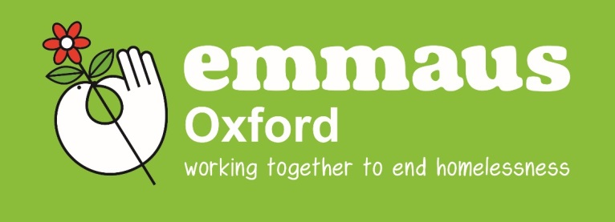

WORK RELATED HEALTH AND SAFETY QUESTIONNAIRE

NAME:_______________________________________________________________

In order to help in your assessment, please complete the following health and safety form:

NO YES DETAILS
High blood pressure/Angina/Heart attack/Stroke
Back related problems

Arthritis

Skin Condition (e,g, eczema)

Liver Disease

Balance Problems (e,g, vertigo)

Work related breathing difficulties
(e,g, asthma, emphysema)
Any other work related physical disability/problem
Mental health issue, such as problems working closely with companions or general public

I agree that the information provided is true and correct. I acknowledge that by giving information which I know to be false, I may be at risk of my licence to occupy being withdrawn.

Signature:__________________________________________________ Date:_________________________

ABILITY TO WORK:

Please confirm your willingness to work 35 hours per week in the community and its social enterprises:

I,______________________________________ confirm my willingness to work 35 hours per week as stated above.

Signature of Applicant:____________________________________________________________________________

DATA SUBJECT CONSENT FORM [Companions/Referrals]:

I, , hereby grant Emmaus Oxford the right to process my personal data for the purposes of: Providing housing and support services / In performance of a contract / Defending and exercising legal rights and Legitimate business interests.
I understand that this data will be stored in paper form in a secure office with restricted access and/or in a password protected folder on the Emmaus Oxford IT system and on the password protected, restricted access INFORM client management software system.
Some data may be processed for the above reasons by third parties and will be retained for the following periods, should I leave Emmaus Oxford:
PERSONAL DATA including name, DOB, NI number, bank account details, medical and criminal histories and other personal history information. This is needed for Emmaus Oxford in the safe and effective provision of the housing and support service, risk management and other legitimate business interests. This data will be stored in secure locations with restricted/password protected security and will be retained by Emmaus Oxford for 2 years after the date of leaving and then destroyed/deleted.
CCTV DATA – for risk management, Health and Safety and security purposes, CCTV is in operation covering the Store [242 Barns Road Oxford] and the entrances to 171 Oxford Road, Oxford, this data is stored for: 1 week or more in the event of an incident investigation, in which case it will be deleted at the end of any formal process.
I understand that I have the right to have access to data held and can request to view and correct it, should it be found to be incorrect it can be corrected.
Any queries or requests regarding Data Protection should be addressed with the Emmaus Oxford Data Coordinator- EDDIE BLAZE
Print name of data subject: .
Signed by data subject: .
Date: / / .
Emmaus respects your confidentiality. Any information provided by you will only be used to assist in the risk assessment, needs assessment and selection process needed to comply with our admissions policy. This information will be kept securely only for as long as it is needed and will not be seen by anyone who is not involved in the above process.

* * * * * *

Once completed, please return this application to:

By Email: referrals@emmausoxford.org

By Post: Admissions
Emmaus Oxford
171 Oxford Road
Cowley
Oxford
OX4 2ES

For Any Queries: 01865 402073

