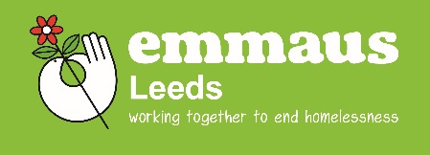

**Furniture Delivery Driver With a Difference**

We’re working together to end homelessness; could you work with us?

We’re looking for a furniture delivery driver to help us meet objectives that will take our business to the next level.

Emmaus Leeds is a different kind of charity/social enterprise because the people we support (known as Companions) are also part of the team that delivers our retail operation. We provide a home and meaningful work to 27 people who have experienced homelessness, offering them a stable home and an opportunity to find a long-term route out of their situation.

The main purpose of the role is to collect and deliver goods alongside Companions.

Regular hours – no lone working. Regular breaks. Lunch and uniform provided.

**It is essential that you have a full clean driving licence which allows you to drive a 3.5-ton van.**

You will need to be a good team player and be able to work effectively under pressure, whilst supporting a diverse group of people. For insurance purposes you also have to be over 21 years old. The role does involve lifting heavy items of furniture and white goods so please bear this in mind when applying.

If you think you have what it takes to take on the challenges of our driving vacancy, we want to hear from you. The position will be subject to an enhanced disclosure and barring check for work with vulnerable adults.

We will be paying £23,625 per year for a 5-day working week (Monday to Friday) of 7.5 hours per day, subject to annual reviews following the successful completion of a 6-month probation period.

We also offer a generous pension package and 25 days holiday per year.

To request an application pack please email [info@emmausleeds.co.uk](mailto:info@emmausleeds.co.uk).

Closing date for applications is 5pm Friday 6th December 2024