Fundraising and Communications Manager
APPLICATION PACK

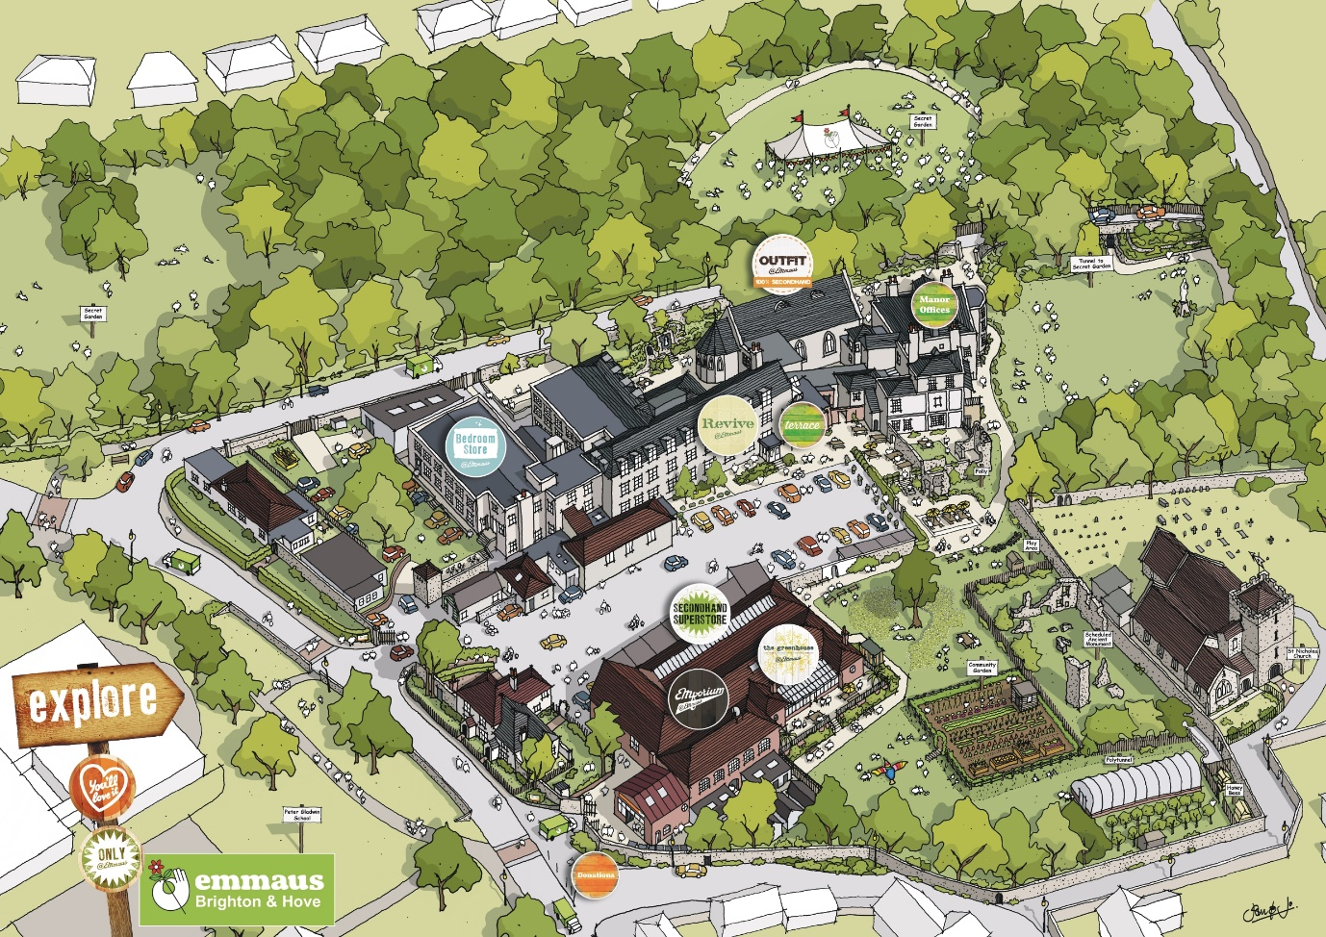
Contents

Introductory Letter 2

About Emmaus 3

The Emmaus Brighton & Hove Community 5

Job Description 6

Person Specification 8

Terms of Employment 10

Application Process 10

Safeguarding and Right of Work in the UK 11

How We Store and Use Your Personal Information 11

Job Application Form 12

Sussex Emmaus, Drove Road, Portslade, East Susses, BN41 2PA
Emmaus Brighton & Hove is a community of Sussex Emmaus, which is a company limited by guarantee No. 3130876 and a Registered Charity No: 1053354
www.emmausbrighton.co.uk

Dear applicant

Thank you for showing an interest in working for Emmaus Brighton & Hove. We are now looking to recruit a Fundraising and Communications Manager (2 days a week).
Salary: £27,000 – £30,000 dependent upon experience (pro rata for 40% FTE).
Hours: Equivalent to 2 days per week, based on a 37 -hour week with the potential to rise to 3 days per week. Standard working hours between Monday to Friday are expected but flexitime is in operation whereby staff can start earlier or later in agreement with his/her line manager and work corresponding.
Location: Emmaus Brighton & Hove or home working. Flexi working can be agreed. Occasional travel within the UK to other Emmaus communities.
Closing date for applications is Monday 1st November 2021
Interviews on Friday 12th November 2021

To apply please send the completed Job Application Form, showing how you meet the person specification and return this to Joel Lewis, Business Manager, by email to joel@emmausbrighton.co.uk or by post to Emmaus Brighton & Hove, Drove Road. Portslade. East Sussex BN41 2PA.

The closing date for the applications is Monday 1st November 2021.

Interviews will take place the following week on Wednesday 10th November 2021.

If you would like to arrange an informal discussion about the role, please email joel@emmausbrighton.co.uk

Kind regards

Karen Chapman
Chief Executive
Emmaus Brighton & Hove

About Emmaus

Our vision: A world in which everyone has a home and a sense of belonging

Emmaus is a homelessness charity with a difference. We don’t just give people a bed for the night; we offer a home, meaningful work, and a sense of belonging.

For many people who have experienced homelessness, losing their self-esteem can be the most damaging part of their experience. Being on your own, with no support around you can be soul destroying, leaving you feeling worthless.

Finding your way out of that situation isn’t easy, particularly when the only options available are temporary fixes, offering a bed for the night but little to occupy your days.

Emmaus is different because it provides a home for as long as someone needs it, in an Emmaus Community. This gives people the opportunity to take stock of their lives, deal with any issues they might have, and often re-establish relationships with loved ones.

“Companion” is the name given to those who live in an Emmaus Community and work in the social enterprise, where they support themselves and one another. There are currently 750 Companions living at 29 Emmaus Communities across the UK.

Rather than relying on benefits, Emmaus uses social enterprise to generate revenue that pays for Companions' home, food, and upkeep, as well as providing a small weekly allowance. This is key to restoring feelings of self-worth, showing Companions that their actions make a real difference, both to their own life, and the lives of others.

How it works

Unlike a lot of provision for homeless people, Emmaus Communities offer a home for as long as someone needs it. This includes a room of their own, food, clothing, and a small weekly allowance.

In return, we ask:
- That Companions work for 40 hours per week, or give as much time as they are able, in the Community's social enterprises.
- That they behave in a respectful way towards one another.
- That no alcohol or illegal drugs are used on the premises.
- That they sign off all benefits, except for housing benefit.

Our impact

Emmaus doesn’t only have a significant impact on the lives of people who have experienced homelessness and social exclusion, it also brings wider social and economic benefits.

Research carried out in 2012 found that for every £1 invested in an established Emmaus Community, £11 is generated in social, environmental and economic returns.

The benefits included:
- Keeping people out of hospital, and helping them to be safe and well, saved the Department of Heath £1,478,506 for NHS and emergency service costs.
- Emmaus saved local government £2,447,612 which would have been spent on hostel accommodation, drug and alcohol services and landfill.
- Keeping people in work and out of prison saved the Ministry of Justice £778,435.

The report found that Emmaus Communities successfully provide a place for people in vulnerable housing situations to rebuild their lives by offering them meaningful work and support. Significant benefits were linked to substantial improvements in Companions’ physical and mental health, including reductions in substance misuse.

The Emmaus UK federation strategic plan

The Emmaus UK federation has recently developed its 2015-2020 Strategic Plan, providing clear direction for where the federation should be by 2020. The plan’s focus is on improving service provision to Companions, becoming financially robust and better known in the UK, and increasing the number of Companion places to meet the ever-increasing demand.

By 2020 we will have:
- 1000 Companion places
- 100 opportunities for non-residential Companions
- Stronger social enterprises
- Structured support and training plans for all Companions
- Companions on all our boards and committees
- More Companions moving into employment
- Started campaigning for change
- Better recognition for the fantastic work we do

The Emmaus Brighton & Hove Community

Our vision is for a thriving, diverse and resilient Emmaus Community, making the most of our amazing asset that is our extensive site in the heart of Portslade Old Village and the passion and skills of the people that make it tick.
A Community that is home. A transformative place where Companionship for formerly homeless people is at the core of what we do – helping vulnerable individuals in crisis when they need it most, providing a home, work and the best life opportunities we can offer, for as long as they need.
A Community that is a destination. A much-talked-about place that attracts people from across the city and beyond to visit, browse, shop, eat and relax – with a reputation for the experience we offer our visitors, from customer service to great bargains, enjoyable events and a unique, positive environment within which Companions play a key role.
A Community that is a hub. A place within the local Community that welcomes all and shares a broad integrated offer with local residents, schools, businesses, charities and volunteers – bringing the local community together to help people help themselves, perhaps establish a home, go to work, celebrate a birthday, learn something new or simply find a sense of belonging and build new relationships over a cuppa.

A place to stay, a place to feel safe, a place to get support, a place to visit, a place to grow, a place to connect, a place to contribute.

Fundraising and Communications Manager Job Description

Job title: | Fundraising and Communications Manager
Reports to: | CEO
Location: | Emmaus Brighton & Hove  Drove Road. Portslade. East Sussex BN41 2PA

Overall Purpose of the Job

The role of the Fundraising and Communications Manager is to build awareness, engagement and support of Emmaus Brighton & Hove (EBH) work, meeting organisational and funding targets.
Responsibilities:
1. Implement the fundraising and marketing strategies.
- Implement an annual communications and appeals calendar, growing our outreach, and maintaining existing and building new support.
- Tailor communications for audience specific fundraising and build support for the cause through targeted profile raising.
- Develop and implement an email data collection programme
- Develop and implement an email communications programme and support development of print newsletter
- Generate photo, video and written content for on and offline communications
- Develop and implement an influencer outreach programme
- Run digital advertising activity (social media and google paid search - training and support available)
- Community management of social media presences, engaging with audiences and driving conversation
- Keep abreast of the homeless issues/housing and the media, particularly on issues which relate to EBH’s activities, and linking with communications.
- Prepare all communications, campaign promotion and support materials for the development of fundraising. This will include developing themes of support and the ‘ask’, researching and sharing topics of interest to build relationships, through newsletters, social media advertising etc.
- Contribute to the guardianship and development of EBH brand.
- Supporting the Business Manager who leads on securing of media coverage by developing editorial content and cultivating influencer relationships

2. Development and delivery of diversified fundraising activities:
- Sustain and build regular and cash giving to EBH through:
- Identifying and targeting key individual donor groups (Trusts and Foundations/Individual Giving/Major Donors/Corporates) and design specific supporter journeys that encourage people to support EBH, build satisfaction and trust; generate further involvement, maximising their giving potential and life-time value.
- Support development and implementation of bi-annual fundraising campaigns
- Providing effective supporter stewardship supporters and build relationships through on and offline communications and sharing stories about our work to increase commitment to EBH.
- Collaborate with the Business Manager to design and install a celebration donor wall on site.
Meeting fundraising targets by:
- Increasing the number of standing orders and one-off donations via digital fundraising activities in collaboration with the Business Manager and Regional Communications Officer.
- Identifying Major Donors in our database who can be developed.
- Progress the Trust and Foundation pipeline submitting applications.
- Account manages existing corporate partners and develop ongoing lower-level corporate giving.
- Report into and collaborate with the Fundraising and Marketing Committee
- Stimulating and supporting others to undertake challenges, and ultimately run third party fundraising activities; and develop donor networks, establishing links with others who have the potential to engage others.
3. General
- Maintain and update the donor pipeline and work with colleagues to ensure accurate records are maintained and conforming to the data protection act.
- Keep abreast of the interests, trends, and practises in the funding environment, exploring new approaches and adapting the strategy as appropriate.
- Keep abreast of social media trends and conversations which present opportunities for engagement
- Monitoring and tracking progress of fundraising and marketing strategies through agreed KPI’s, providing analysis of the levels of success; including keeping up to date records, analysing and evaluating activities to inform plans.
- Contribute to the work of other EBH and EUK colleagues in fundraising and communications, and relationship building, including the timely provision of information.
- Represent EBH at meetings, events and other networks as appropriate.
- Undertake any appropriate duties that may be requested by the CEO.
Person Specification
Experience:
As an experienced communicator/fundraiser you will have a proven track record in achieving targets, planning and evaluating campaigns, including:
- A proven track record of managing the growth of individual income streams.
- Proven experience of increasing digital marketing engagement through website development and social media platforms.
- Proven experience of developing creative content for digital channels
- Leading on and carrying out donor prospect research and developing new donor relationships.
- Specific experience of building and upgrading donor relationships.
- Experience of working with online influencers and managing social media/Google paid search advertising preferred by not essential

Knowledge:
- Able to demonstrate understanding of the challenges of homelessness.
- Good understanding of charity and direct marketing legislation, General Data Protection Regulation and Chartered Institution of Fundraising Guidelines
Skills:
- Excellent ability to creatively write a range of materials suitable for different audiences and present it in an engaging and appropriate form.
- Excellent personal skills with a proven ability to engage, inspire and support people to undertake fundraising and communications activities.
- Strong mobile phone photography and video skills. Basic video editing skills preferred
- Target-focused with proven experience in delivering to income targets.
- Excellent research and analytical skills
- Good time management skills, able to work under pressure and meet deadlines.
- Ability to build lasting and positive relationships with individual donors.
- Good listening and oral communication skills
Good IT skills, MS Office, Social Media Channels, Word Press,
Personal Attributes:
Your strategic approach to fundraising will be analytical and reflective. At the same time, you will be passionate about EBH work, understand motivations behind why individuals give and be able to communicate a compelling case for support.
Your infectious enthusiasm and passion for the causes you work on persuades key stakeholders to offer their support.
As a team-player, you are skilled at building and managing relationships with internal and external stakeholders. Open to new ideas, you take a proactive, innovative, and creative approach to your work.
You will also be able to:
- Work proactively on own initiative.
- Remain positive and quickly recover from setbacks.
- Work in a small dynamic team with limited access to resources.
- Be flexible and willing to support others at times when organisational priorities take precedence.
- Work in a sensitive and appropriate manner
Equal Opportunities
We value diversity and seek to reflect this in our staff team. We welcome applications from people from all sections of the community, irrespective of race, colour, gender, age, disability, sexual orientation, religion, or belief.
Policies and Practice
The successful candidate must have a commitment to EBH values and mission; comply with EBH policies and practice, including our code of conduct and safeguarding policies.
Eligibility
Only people eligible to work in the UK can apply for this position.

Safeguarding and Right of Work in the UK
The role will involve working with Companions and in the Community, therefore the successful applicant will need to have a Disclosure and Barring Service (DBS) check carried out. This is to check the criminal records and that the person is not barred from working with ‘adults at risk’. Some Companions can be classed as adults at risk. An adult at risk is anyone that has one or more of the following:
- Does not understand certain decisions or transactions
- Are unaware of their rights or how to complain
- Have communication difficulties
- Have limited life experiences
- Are socially isolated
- Have low self esteem
- Are dependent on others for their basic needs

The additional details form is needed to check any previous convictions. After interviews, the successful candidate will need to provide evidence of right to work in the UK and complete a DBS check.
How We Store and Use Your Personal Information
Your CV and other information will be stored in a password protected folder throughout the interview process. It will be stored for six months, to enable equality monitoring and to enable us to contact you in the future should any other suitable posts become available. However, if at any time you wish us to delete your information, then please do not hesitate to contact us and it will be destroyed.
The CV only will be passed onto other members of the panel. But before it is passed on, the personal information will be removed from your CV. This includes:
- Name
- Address
- Age
- Marital Status
This is to protect your personal information, but also to enable us to shortlist ‘blind’, so that we are fair and equitable to encourage a diverse workforce.
Read our Privacy Statement for Employees and Potential Employees using the link below:

http://www.emmausbrighton.co.uk/who-we-are/our-strategic-plan/privacy-statements

Emmaus Brighton & Hove

Job Application Form

Address – Emmaus Brighton & Hove, Drove Road, Portslade, East Sussex, BN41 2PA

Tel – 01273 426470 Email – joel@emmausbrighton.co.uk
Registered charity no - 1053354
www.emmausbrighton.co.uk

Please complete this form in black ink or type, and return by email or post to Joel Lewis, Business Manager, at the above address or via joel@emmausbrighton.co.uk. Please complete this form accurately, giving as many details as possible of your skills and experience relating to the job. Short-listing will be based on the information gathered from this form, read in conjunction with the person specification for the role.

Please state where you saw this post advertised:

Job Details
Title: | First name | Surname:

Address: | Email address:
 | Home Tel:
 | Work Tel:
 | Mobile Tel:

Are there any restrictions regarding your employment? E.g., Do you require a work permit? | Yes*/no
*If you answer yes, please provide details below

How much notice are you required to give your current employer?

Reasons for Applying
Please outline your reasons for applying for the post. (Please continue onto a separate sheet if necessary)
Education and Qualifications
Please list any qualifications you have gained or are about to gain (most recent first).
Date | Name of School / College / University / Training Body | Type of Qualification | Subject | Result
Training
Please list any training you have received, or courses you have attended that you feel are relevant to the post (most recent first).
Date | Details of Training Course
Past Employment Details
Please start with your most recent / current employment. Briefly describe the main duties and responsibilities.
Employer’s Name & Address | Job Title | Brief Description of Duties | Date |  | Salary | Reasons for Leaving
 |  |  | From | To

Relevant Skills and Experience
Please provide information that shows how you meet the person specification and how your skills and experience support your application for the position. The person specification and job description relevant for this section can be found in the application pack. (Please continue onto a separate sheet if necessary)

Other Interests
Please give details of any vocational activities or voluntary commitments:

Referees
Any offer of employment is dependent on receipt of 2 satisfactory references. Please provide details of two referees who can comment on your suitability for this post. We would normally wish to see one reference from your present or most recent employer. References will only be taken up for the successful candidate.
Referee 1: | Referee 2:
Name: | Name:
Position: | Position:
In what capacity does this person know you: | In what capacity does this person know you:
Organisation: | Organisation:
Address: | Address:
Tel: | Tel:
Email: | Email:

Declaration and Signature
I confirm that the information contained in this application form is accurate and correct.

Signature ___________________________________________ Date ______________________

By signing and returning this application form you consent to Emmaus using and keeping information about you relating to your application or future employment. This information will be used solely for recruitment purposes and will be retained on file for 6 months.

In addition to this, Emmaus may wish to hold your details on file for consideration for any future vacancies that may arise. Please indicate if you wish to be considered for other posts which may arise within the next 6 months: Yes/no

Thank you for completing this application form.
Please forward this together with other associated forms to the address specified at the beginning of this form

